1. One-to-Many Relationship (1:*) in Power BI
Definition:
One record in a dimension (lookup) table relates to multiple records in a fact table.
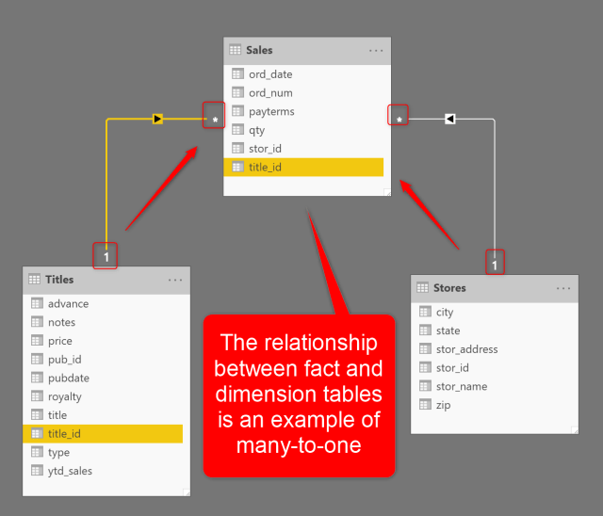
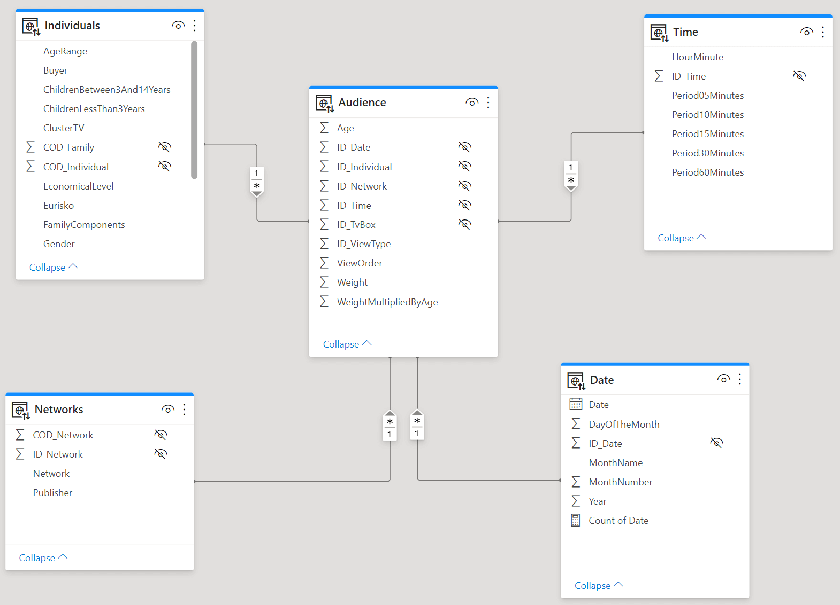
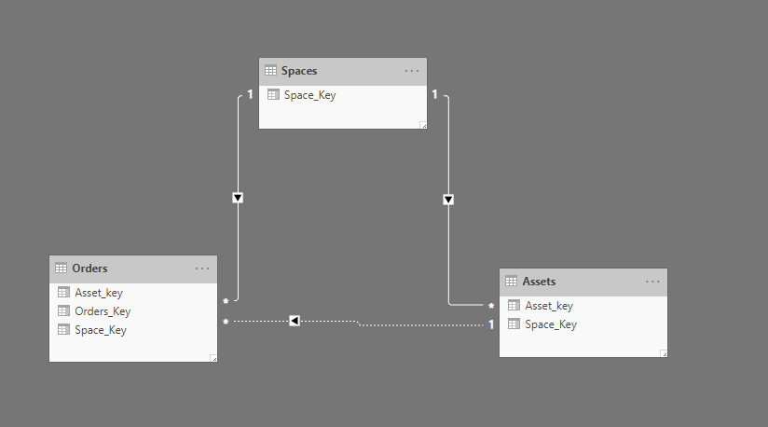
Correct Examples
- Customers → Sales
  - Customers[CustomerID] → Sales[CustomerID]
- Products → OrderDetails
  - Products[ProductID] → OrderDetails[ProductID]
- Date → Transactions
  - Date[DateKey] → Transactions[DateKey]
Common Errors & Reasons
Error | Reason
Duplicate values on the “one” side | Dimension table is not unique
Relationship not active | Existing active relationship already exists
Blank values | Null keys break relationship logic
Data type mismatch | Text vs Number columns
How to Fix
- Ensure unique keys in the dimension table
- Remove duplicates using Power Query → Remove Duplicates
- Align data types
- Prefer Star Schema

2. Many-to-Many Relationship (:)
Definition:
Multiple records in Table A relate to multiple records in Table B.

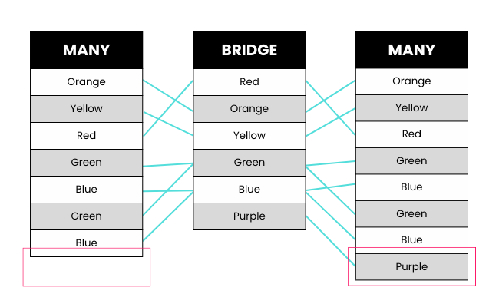
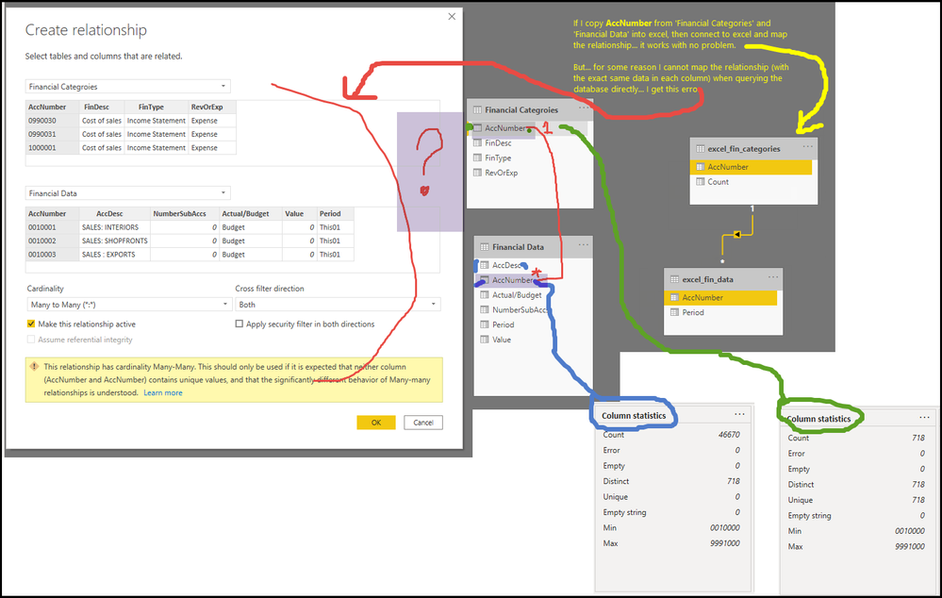
Real-World Examples
- Students ↔ Courses
- Employees ↔ Projects
- Products ↔ Suppliers
Why It Causes Problems
- Incorrect totals
- Double counting
- Ambiguous filter paths
- Slow performance
Power BI Errors
- Measures return inflated values
- Filters do not propagate as expected
Best Practice Solution (Recommended)
Use a Bridge Table
Example:
Students ──< StudentCourse >── Courses
- StudentCourse contains unique combinations
- Convert : into two 1: relationships*

3. Many-to-One Relationship (*:1)
Definition:
Many records in one table map to a single record in another table
(Technically same as 1:* but viewed from the opposite side)
Examples
- Sales → Customers
- Transactions → Date
- Attendance → Employees
Key Point
- Always ensure lookup table = ONE side
- Fact table = MANY side

4. How to Analyze Data Before Creating Relationships (Critical Tips)
Step-by-Step Approach
- Understand Business Process
  - What is fact? What is dimension?
- Identify Grain
  - One row = one transaction? one day?
- Check Uniqueness
  - Dimension keys must be unique
- Validate Data Types
  - Integer ↔ Integer, Date ↔ Date
- Remove Junk Data
  - Blanks, nulls, mismatched keys
- Create Star Schema
  - Avoid snowflake unless required
Pro Tips
- Use Power Query for cleansing
- Never relate two fact tables directly
- Avoid bi-directional filters unless justified

5. What Is Cross Filter Direction?


Types
- Single Direction (Recommended)
  - Filters flow from Dimension → Fact
- Both Direction
  - Filters flow both ways
When “Both” Causes Errors
- Circular dependency
- Ambiguous filter paths
- Incorrect measures
Best Practice
- Use Single by default
- Use Both only for bridge tables or advanced scenarios

6. What Is OneLake Catalog?
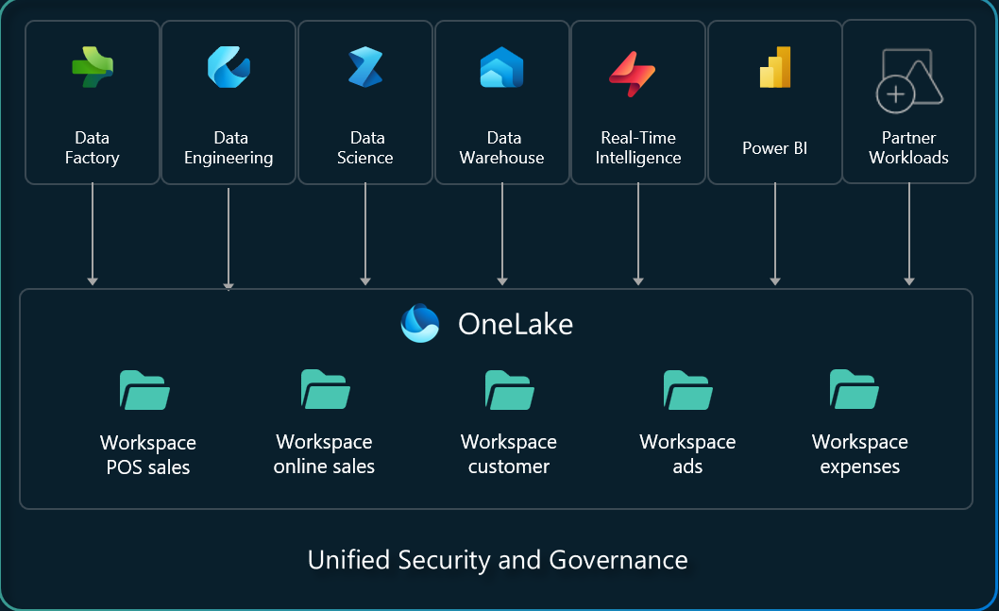
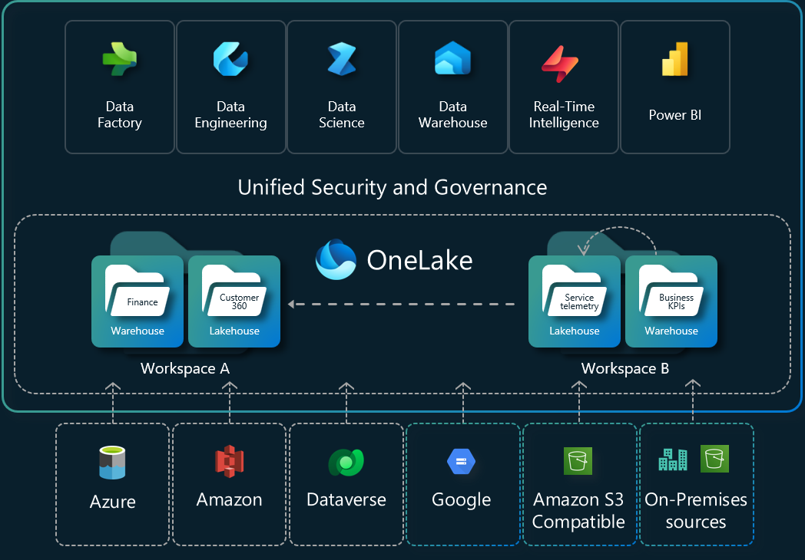
OneLake is the centralized data lake for Microsoft Fabric.
Key Features
- One copy of data for all tools
- Integrated with Power BI, Synapse, Data Factory
- No data duplication
- Enterprise-grade security
Simple Explanation
OneLake = One Data Lake for the entire organization

7. How to Create Relationships Between Two Datasets in Power BI
Scenario 1: Same Power BI Model
- Load both datasets
- Go to Model View
- Drag common key column
- Set:
  - Cardinality
  - Cross filter direction
  - Active relationship
Scenario 2: Different Sources
- Ensure same key format
- Clean data in Power Query
- Create bridge table if needed
Scenario 3: Two Fact Tables
Wrong:
FactSales ↔ FactReturns
Correct:
FactSales → Date
FactReturns → Date

Final Best-Practice Checklist
- Prefer Star Schema
- Avoid Many-to-Many unless unavoidable
- Dimension tables must be clean & unique
- Use bridge tables
- Validate filters using simple visuals
- Test totals after relationship creation

If you want, I can next provide:
- Real-world Power BI case studies
- Common interview questions
- Step-by-step demo dataset
- DAX impact due to wrong relationships
Tell me how deep you want to go.

